Networking in CAN Technology

Introduction

Controller Area Network (CAN) is a serial network that was originally designed for the automotive industry, but has also become a popular bus in industrial automation as well as other applications. The CAN bus is primarily used in embedded systems, and as its name implies, is the network established among microcontrollers. It is a two-wire, half duplex, high-speed network system and is well suited for high speed applications using short messages. Its robustness, reliability and the large following from the semiconductor industry are some of the benefits with CAN.

CAN provides a safe communication channel to exchange up to 8 bytes among several network nodes. Additional network functionality, such as which node talks to which others, when to trigger transmit messages, how to transmit data longer than 8 bytes - all of these functions are specified in so-called higher-layer protocols (in network terms, CAN is a layer 2 implementation - higher layers are implemented in software). Some of the more popular higher-layer CAN bus protocols are CANopen, DeviceNet and J1939.

CAN can theoretically link up to 2032 devices (assuming one node with one identifier) on a single network. However, due to the practical limitation of the hardware (transceivers), it can only link up to 110 nodes (with 82C250, Philips) on a single network. It offers high-speed communication rates up to 1 Mbits/sec thus allowing real-time control. In addition, the error confinement and the error detection feature make it more reliable in noise critical environments.

Networking in the OSI Model

It is very important to learn the OSI model, since it is the foundation to understanding the networking world. The Open Systems Interconnection Reference Model (OSI Reference Model or OSI Model) is an abstract description for layered communications and computer network protocol design. It is used to describe the flow of data between the physical connection to the network and the end-user application.

This model initial development in 1977, by the ISO (International Standards Organization), redesigned and released for general use in 1984, is the best known and most widely used model for describing networking environments. In its most basic form, it divides network architecture into seven layers which, from top to bottom, are the Application, Presentation, Session, Transport, Network, Data-Link, and Physical Layers.

|  |  |  |  |  |
| --- | --- | --- | --- | --- |
| Layer Number | Layer Name | Data Unit Name | Service and hardware devices | Functionality |
| 7 | Application | Data | Some Gateways | Program to program transfer of data |
| 6 | Presentation | Data | Redirector Service | Displaying the information |
| 5 | Session | Data |  | Establishing, maintaining and coordinating communication |
| 4 | Transport | Segment |  | Accurate delivery, service quality |
| 3 | Network | Packet | Most Gateways, Routers | Transport routes, message handling and transfer |
| 2 | Data Link | Frame | Switches, bridges | Coding, addressing, and transmitting information |
| 1 | Physical | Bit | Repeaters | Hardware connections |

Layer 7 - Application Layer: The application layer is the OSI layer closest to the end user, which means that both the OSI application layer and the user interact directly with the software application.

Layer 6 - Presentation Layer: The presentation layer provides a variety of coding and conversion functions that are applied to application layer data. These functions ensure that information sent from the application layer of one system would be readable by the application layer of another system. Some examples of presentation layer coding and conversion schemes include common data representation formats, conversion of character representation formats, common data compression schemes, and common data encryption schemes.

Layer 5 – Session Layer: The session layer establishes, manages, and terminates communication sessions. Communication sessions consist of service requests and service responses that occur between applications located in different network devices.

Layer 4 - Transport Layer: The transport layer accepts data from the session layer and segments the data for transport across the network. Generally, the transport layer is responsible for making sure that the data is delivered error-free and in the proper sequence. Flow control generally occurs at the transport layer.

Layer 3 - Network Layer: The network layer defines the network address, which differs from the MAC address. Some network layer implementations, such as the Internet Protocol (IP), define network addresses in a way that route selection can be determined systematically by comparing the source network address with the destination network address and applying the subnet mask.

Layer 2 – Data Link Layer: The data link layer provides reliable transit of data across a physical network link. Different data link layer specifications define different network and protocol characteristics, including physical addressing, network topology, error notification, sequencing of frames, and flow control. Network topology consists of the data link layer specifications that often define how devices are to be physically connected, such as in a bus or a ring topology.

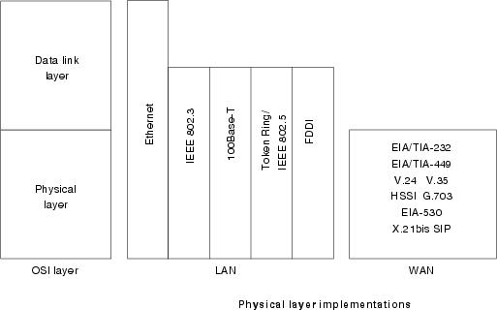Layer 1 – Physical Layer: The physical layer defines the electrical, mechanical, procedural, and functional specifications for activating, maintaining, and deactivating the physical link between communicating network systems. Physical layer specifications define characteristics such as voltage levels, timing of voltage changes, physical data rates, maximum transmission distances, and physical connectors. Physical layer implementations can be categorized as either LAN or WAN specifications. The following figure illustrates some common LAN and WAN physical layer implementations.

Network Topology

The topology of a network describes the physical connection structure between the nodes of a communication network. This kind of connection structure determines the implementation of the physical network, the limits of applications, and the parameters of the networks.

Types:

Star Topology

All are connected to a central node via point-to-point connections.

|  |  |
| --- | --- |
| Advantage | Disadvantage |
| Directly connected to central node from every node | Generally high total length of connections if node are ordered as geographical line |
| Simple integration for more nodes | Central node requires N interfaces for N nodes |
| Easy to implement with optical transmission media | Communication between nodes ONLY possible through central node |
|  | If central node fails, no communication possible |

Star topology

Bus Topology

It is commonly known by the electrically passive connection of all nodes to a common medium.

|  |  |
| --- | --- |
| Advantage | Disadvantage |
| Lower cabling costs | Limited bus length and number of nodes |
| Easy connecting to a node | Stub length for connecting to nodes could be strictly limited due to terminations of resistors |
| Simple to extend more nodes without interruption | Complicated to implement with optical media |
| Failure of one node does not affect the rest | Node identification required |
| Arbitrary logical communication possible |  |

Bus topology

Tree Topology

When arbitrary branching is possible via active or passive elements, it is called tree topology.

|  |  |
| --- | --- |
| Advantage | Disadvantage |
| Low cabling and installation costs | When active branching element are used, their cost are a disadvantage |
|  | Possible to have branches of considerable length |

Tree topology

Ring Topology

A ring topology is defined by a closed chain of addressed point-to-point connections.

|  |  |
| --- | --- |
| Advantage | Disadvantage |
| Possible implementation of extended network | Total system fails when one of the node fails |
| Very well suited for the use of optical transmission media | When integrate a new node or replace a node, interruption is needed |
| Simple node identification possible of nodes possible |  |

Ring topology

CAN Devices for Network Topology

Electrical signals transmitted on the bus line will be reflected at the ends of an electrical line as well as at drop lines if no appropriate measures have been taken. For the correct interpretation, it is necessary that superimposed signal reflections have attenuated sufficiently at that time when the bit level is sampled.

Reflections at drop lines can be minimized by very short drop lines. Therefore the highest possible product of transmission rate and bus line length can be achieved with a line topology that is as close as possible to a single line structure and terminated at both ends.

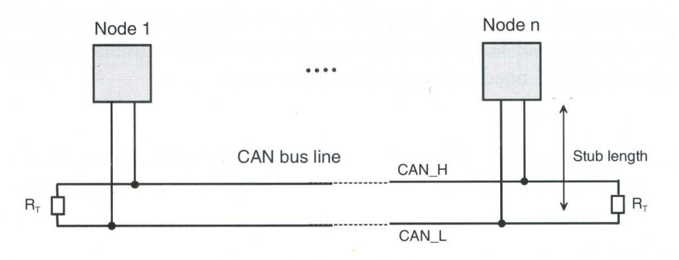

Bus topology according to [ISO99-2]

By means of repeaters, bridges or gateways it is possible to overcome the limitations of the basic line topology of CAN networks and thus adapt the network topology according to the geographical needs of a specific application,

Repeater

A repeater transfers an electrical signal from one physical bus segment to another segment on the physical layer. Therefore the signal is regenerated and transparently passed on to the other segment. Thus a repeater divides a bus into two physically independent segments. Regarding signal propagation a repeater introduces an additional signal propagation time equal to its delay time. The logic of the repeater has to accept input signals from both connected bus segments and has to ensure that a signal from one side is not looped back. The additional delay time introduced by a repeater is about 250 … 350 ns and thus reduces the possible maximal bus line length by approximately 50 – 70 m per repeater.

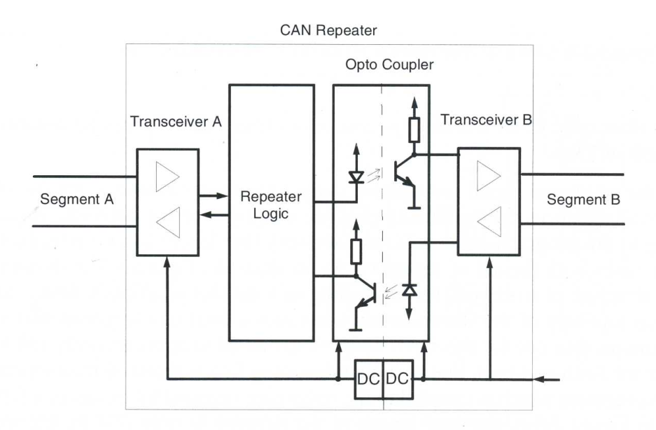

Block diagram of a CAN repeater with galvanic decoupling of bus segments

The use of repeaters basically reduces the maxima possible extension of the network. This example shows that an optimum adaptation to geographical restrictions is possible using repeaters.

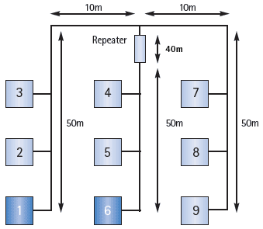

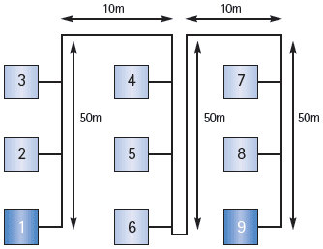

**Conventional bus structure**the distance between the two nodes  
furthest apart (1/9) is 220 meters

**Extended structure with drop line**  
the distance between the two nodes  
furthest apart (1/6 or 6/9) is 150 meters

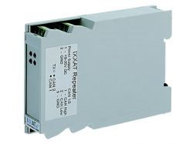**Technical Data**

ISO 11898-2 CAN Repeater (with Low-Speed Option)

|  |  |
| --- | --- |
| Display | Transmit (2 green LEDs), defective segment (2 red LEDs) |
| CAN bus interface | ISO 11898-2 with CAN choke. Screw terminals. CAN 1, CAN 2 and power supply are galvanic isolated against each other. CAN termination resistors are integrated (switchable). |
| Baudrate | Up to 888 kbps |
| Delay | 200 ns (corresponds ~40 m (~120ft.) bus length) |
| Power supply | 9-35 V DC, 1.5 W typ., through terminals |
| Temperature range | -20 ºC ... +70 ºC |
| Housing, size | Plastic enclosure, 110 x 75 x 22 mm |

Bridge

A bridge connects to separate networks on the data link layer. Bridges inherently provide a storage function and can forward messages or parts of messages in an independent, time-delayed transmission between network segments. Bridges store and forward complete or parts of messages which are not local, while repeaters forward all electrical signals.

It is possible to realize an organizational structuring of multi-segment networks by forwarding only those messages from one network to another, also to control and reduce the bus loads of different bus segments.

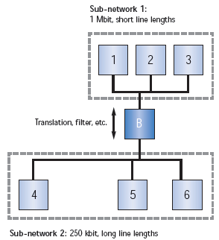

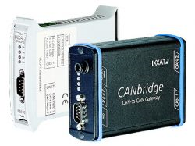**Technical Data**

Configurable CAN/CAN Bridge

|  |  |
| --- | --- |
| Microcontroller | Fujitsu MB90F543 |
| Memory extension | 128 k Flash on-chip, 6 k RAM on-chip, 256 Bytes I2C EEPROM |
| CAN controller | 2 x CAN on-chip, CAN 2.0A, 2.0B |
| CAN bus interface | 2x ISO 11898-2 (High Speed), as an option galvanic isolated or 1x ISO 11898-2 and 1x ISO 11898-3 (low-speed) |
| Serial interface | RS232 for device configuration |
| Voltage supply | 9-36 V (**Industrial Version**), 7-16 V (**Automotive Version**), 1.5 W |
| Temperature range | -20 ºC ... +70 ºC |
| Certification | CE |
| Housing | Robust metal housing approx. 100 x 85 x 32 mm or plastic DIN rail housing approx. 110 x 75 x 22 mm |

|  |
| --- |
|  |

Gateway

A gateway provides a connection between networks of different protocols. And that means performing translation between different communication systems.

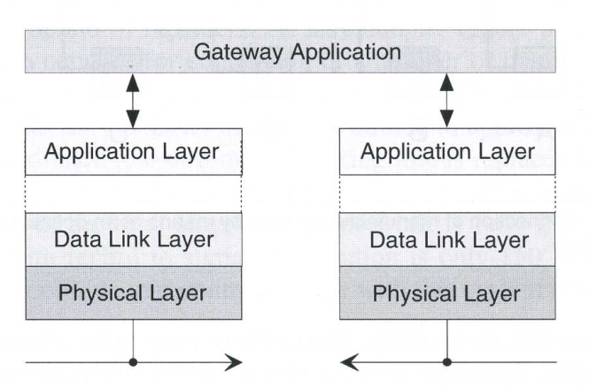

Via a gateway CAN network can be connected to any other type of network including the Internet. CAN gateways offer interesting opportunities with respect to remote maintenance and diagnosis of CAN-based systems. It is possible to connect an CAN-based network with an Ethernet/TCP/IP-based Intranet or a via serial/PPP/Modem-Interface to a remote PC for wireless monitoring and control.

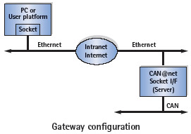

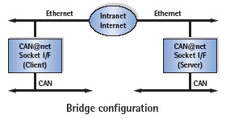

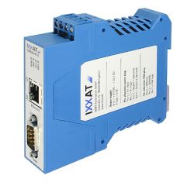

**CAN-Ethernet Gateway**

**Technical Data**

|  |  |
| --- | --- |
| PC bus interface | 10/100 Mbit/s Ethernet (10Base-T/100Base-T), Autodetect, RJ45 connector |
| IP address allocation | DHCP, via PC tool |
| Microcontroller | Freescale MCF5235, 150 MHz |
| Memory extension | 8 Mbyte DRAM, 4 Mbyte Flash |
| CAN controller | SJA1000 |
| CAN bus interface | ISO 11898-2, Sub D9 galvanically decoupled (500V) |
| Current supply | 9-32 V DC, 3 W |
| Temperature range | -20 ºC ... +70 ºC |
| Certification | CE, FCC, CSA |
| Housing | Plastic housing for top hat rail mounting |
| Size | approx. 22,5 x 100 x 115 mm |

|  |
| --- |
|  |

Network with Repeaters, bridges and gateways:

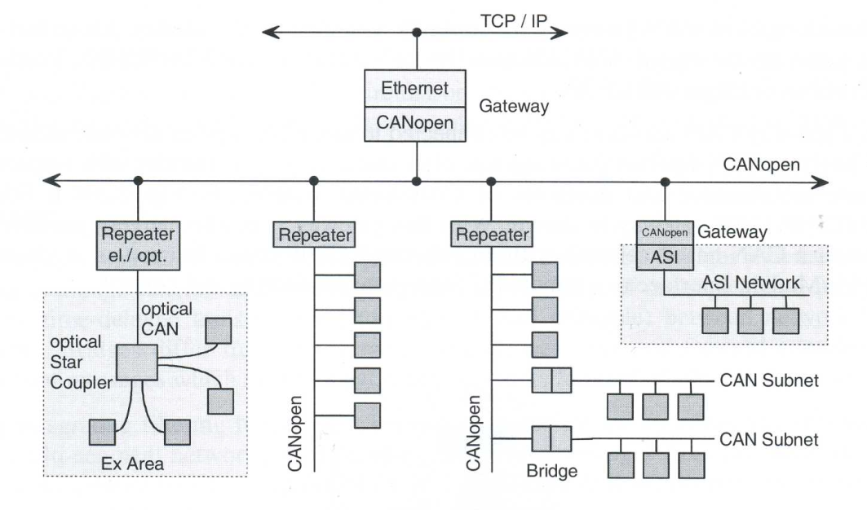

Sources:

Controller Area Network – Konrad Etschberger , IXXAT Press 2001

<http://www.semiconductors.bosch.de/pdf/can2spec.pdf>

<http://www.cisco.com/en/US/docs/internetworking/technology/handbook/Intro-to-Internet.html>

<http://www.can-cia.org/index.php?id=517>

<http://www.semiconductors.bosch.de/en/20/can/index.asp>